Chanceller Waters

Assignment 1.2

Link to 310 repository:
https://github.com/cwaters-00/csd-310.git

Screenshot of 310 repository:
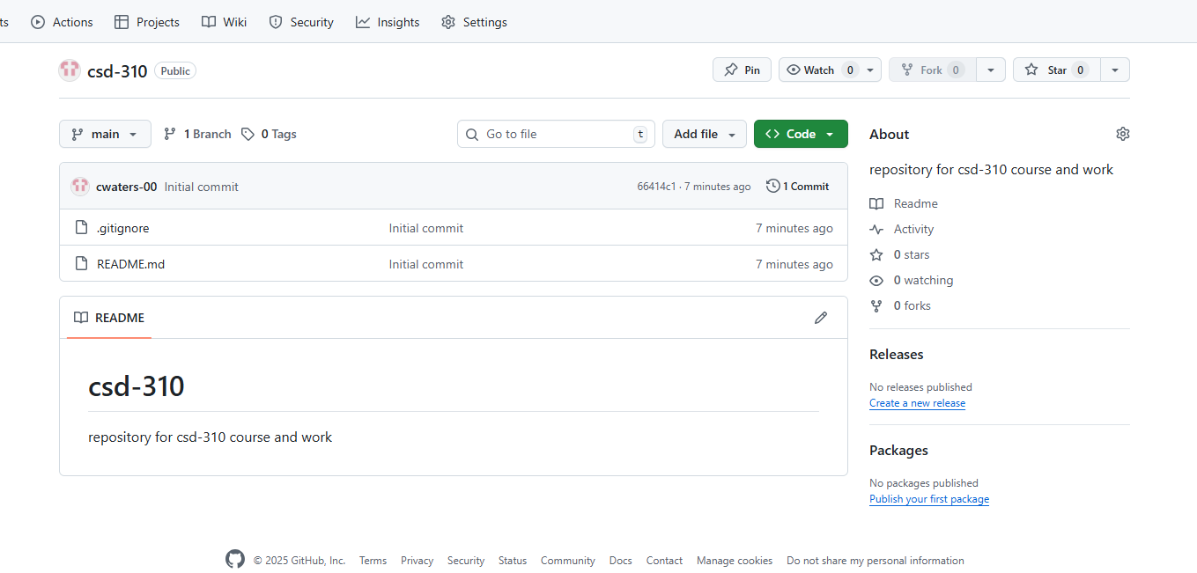

Screenshot of additional directory+ Changes:

